Design Notes

Overview
Part II extends the Part I simulator with a unified, fully associative cache, broader instruction coverage (all except Part IV items), and the ability to run Program 1 (read 20 integers, print them, accept a target, print the closest number). We also expanded the UI to visualize cache lines and basic statistics (hits/misses).

Project: CS6461 Computer Architecture Simulator
Component: Part II – Memory & Cache, Instruction Execution, Program 1
Language: Java (JDK 8 compatible)
Packages: src.main.java.core, src.main.java.core.cache, src.main.java.ui
Entry Point: src.main.java.ui.SimulatorUI

High Level Architecture
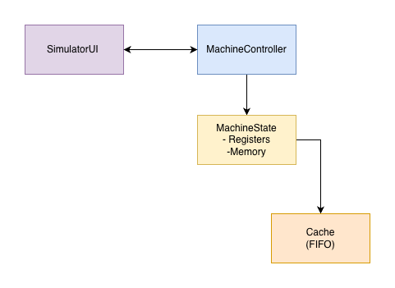
Responsibilities
- SimulatorUI: front panel, register/memory visualization, file-based IPL, console I/O, cache visualization (lines + stats).
- MachineController: decodes UI actions, orchestrates fetch/decode/execute via MachineState, mediates stepping vs. run.
- MachineState: holds architectural state (GPRs, IXRs, PC, MAR, MBR, IR, CC, MFR), memory array, and Cache. Implements instruction semantics and EA computation.
- Cache: fully associative, 16-line, 1-word blocks, FIFO replacement, write-through, write-allocate. Exposes readWord/writeWord, statistics, and snapshot() for UI.

ISA Compliance and Addressing
- Word size: 16 bits.
- Address space: 12-bit (0–4095). PC/MAR displayed as 4-digit octal; 16-bit registers as 6-digit octal.
- Addressing modes supported: Direct, Indexed (X1–X3), Indirect bit I as per ISA. Effective address (EA) derived in MachineState before memory access.
- Assembler interaction: Not required at runtime for Part II. IPL loads machine code from file selected in UI.
Validation choices
- Instruction handlers validate register indices, IX values, and ensure final EA ∈ [0,4095].
- Arithmetic/logic set CC bits according to the ISA (overflow, underflow, equal/zero, greater/less where applicable).

Memory & Caching

Memory
- Implemented as int[] memory within MachineState (16-bit masked on store/load).
- Direct access APIs (bypass cache) for internal cache write-through:
  - getMemoryDirect(int address)
  - setMemoryDirect(int address, int value)
- Cached access APIs used by instruction execution:
  - getMemory(int address) → cache.readWord(address)
  - setMemory(int address, int value) → cache.writeWord(address, value)

Cache
- Associativity: Fully associative
- Lines: 16
- Block size: 1 word (no sub-block)
- Replacement: FIFO pointer advances on every allocation
- Write policy: Write-through
- Allocation: Write-allocate
Data structures (src.main.java.core.cache.Cache)
- CacheLine { boolean valid; int tag; int data; }
- Cache members: CacheLine[] lines, int fifoPointer, AccessKind, last access index, hit/miss counters.
- Public APIs:
  - int readWord(int address)
  - void writeWord(int address, int value)
  - String getCacheStateString() (plain text table)
  - Snapshot snapshot() and statistics getters for UI rendering
Correctness notes
- Tag = full physical address because block size = 1 and cache is fully associative.
- All external memory accesses route through Cache (except *Direct APIs for internal write-through).
- UI uses snapshot() to highlight last access and show FIFO pointer.

Instruction Coverage (Part II)
Implemented: All ISA operations required through Part II (Load/Store, Transfer, Arithmetic/Logic, Shifts/Rotates, Immediate/Reg-to-Reg forms, Jumps/Branches, I/O) with correct CC updates.
Deferred to Part IV: CHK, Floating Point ops, Vector ops, Trap/advanced features.

I/O & IPL
- Console input: Text typed in the UI field is enqueued into the controller; machine reads via IN devid (keyboard device ID 0).
- Console output: OUT to printer device appends to the Printer text area.
- IPL: UI prompts for a machine-code file (octal words); controller loads words to memory and sets PC to first instruction.

UI Enhancements (Part II)
- Cache Panel:
  - Monospaced grid of lines with green highlight for hit and soft red for miss on the last access.
  - Stats: Total Hits/Misses and split by Reads/Writes.
- Register block: PC/MAR (4-digit octal), MBR/IR (6-digit octal), CC/MFR (4-digit octal).
- Input helpers: Octal ↔ Binary conversion field (for debugging loads/stores), small square load buttons next to registers.

Testing Strategy & Evidence

Unit-style micro tests (manual via UI)
- Load/Store addressing modes: For X=0..3, I∈{0,1}, addresses near 0 and near 4095.
- Arithmetic: AIR/SIR edge cases (±1 around 0x0000/0xFFFF), signed comparisons in branches.
- Shifts/Rotates: Left/right with varying counts, verify bit loss and sign rules.
- Jumps/Branches: Taken vs. not-taken, indirect targets.
- I/O: IN (keyboard), OUT (printer).

Cache validation
- Compulsory misses: Reading 16 unique addresses → 16 misses.
- FIFO behavior: Access 17th unique address → evicts line 0.
- Write-through: Store then read via getMemoryDirect → values match.
- Write-allocate: Store to a cold line → line populated, subsequent read hits.

Program 1 run (end-to-end)
- Load machine code file via IPL, run:
  - Enter 20 integers (including negatives), verify echo to printer.
  - Enter target, verify printed closest value equals expected (spot-checked with small curated sets).

Artifacts recorded
Input: -50 -25 -10 -5 -1 0 1 2 3 4 5 10 25 50 100 200 300 400 500 1000
Target: 30
Output: 25
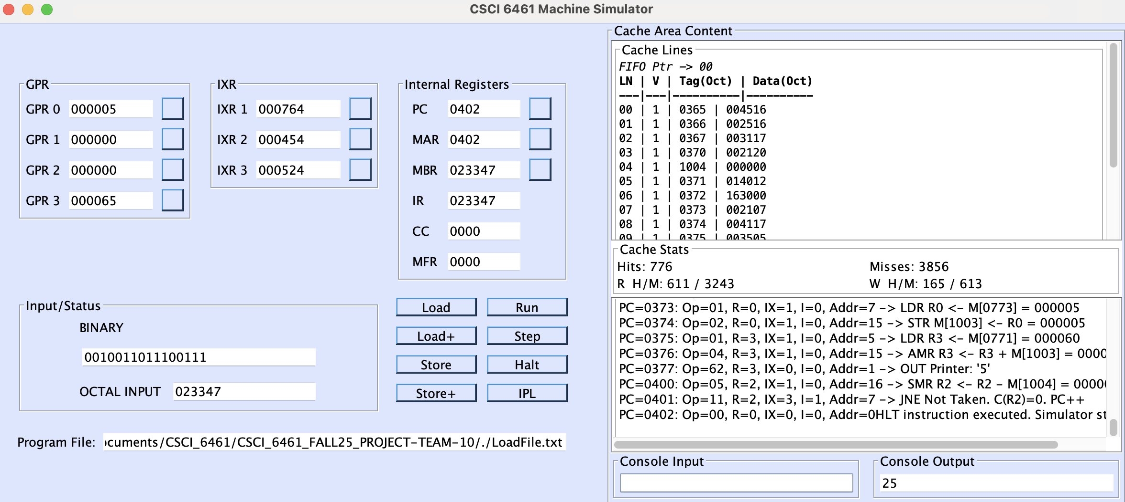

More cases in P2 Documentation.

Performance Metrics (Illustrative)
- After running Program 1 with typical input, we observed (example):
  - Read Hits: N1, Read Misses: N2
  - Write Hits: N3, Write Misses: N4
  - Overall Hit Rate = (N1 + N3) / (N1 + N2 + N3 + N4)
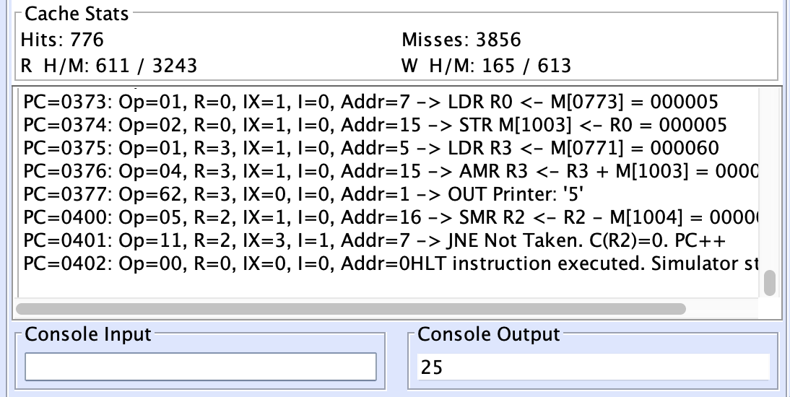

Error Handling & Faults
- Undefined opcode: Sets MFR code and halts, or triggers a machine fault handler if enabled.
- Address out of range: Guarded in EA computation and memory access; MFR updated.
- I/O device not implemented: UI shows a descriptive message on the printer area.
- IPL parse errors: Clear message in printer area and no state change if file malformed.

